**BANK LOAN REPORT QUERY DOCUMENT**

**BANK LOAN REPORT | SUMMARY**

**KPIs**

**TOTAL APPLICATIONS**

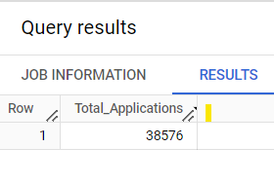

**TOTAL MTD APPLICATIONS**

SELECT Count(Distinct id) as Total_MTD_Applications

FROM `sql-project-413513.Financial_Analytics.Loan Repayment`

WHERE issue_date BETWEEN '2021-12-01' and '2021-12-31'

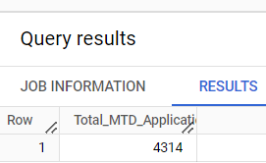

**MTD TOTAL FUNDED**

SELECT sum(loan_amount) as MTD_Total_Funded_Amount

FROM `sql-project-413513.Financial_Analytics.Loan Repayment`

WHERE issue_date BETWEEN '2021-12-01' and '2021-12-31'

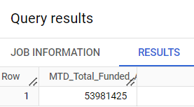

**PMTD TOTAL FUNDED AMOUNT**

SELECT sum(loan_amount) as PMTD_Total_Funded_Amount

FROM `sql-project-413513.Financial_Analytics.Loan Repayment`

WHERE issue_date BETWEEN '2021-11-01' and '2021-11-30'

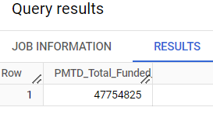

**TOTAL MONEY RECEIVED**

SELECT sum(total_payment) as Total_Money_Receieved_By_Bank

FROM `sql-project-413513.Financial_Analytics.Loan Repayment`

WHERE issue_date BETWEEN '2021-12-01' and '2021-12-31'

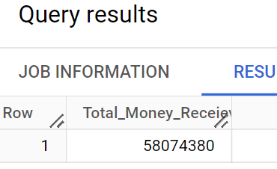

**AVG INT RATE**

SELECT AVG(int_rate)*100 as avg_int_rate

FROM `sql-project-413513.Financial_Analytics.Loan Repayment`

WHERE issue_date BETWEEN '2021-12-01' and '2021-12-31'

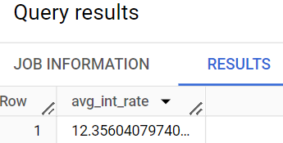

**AVG DTI**

SELECT AVG(dti)*100 as avg_dti

FROM `sql-project-413513.Financial_Analytics.Loan Repayment`

WHERE issue_date BETWEEN '2021-12-01' and '2021-12-31'

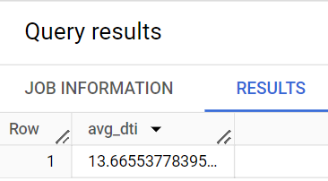

**GOOD LOANS**

**Good Loan Percentage**

SELECT Count(CASE WHEN loan_status = 'Fully Paid'then id

WHEN loan_status= 'Current'then id END)*100 / count(id) as good_loan_percentage

FROM `sql-project-413513.Financial_Analytics.Loan Repayment`

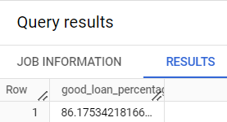

**Good loan Application’**

SELECT count(id) as Good_loan_Application

FROM `sql-project-413513.Financial_Analytics.Loan Repayment`

WHERE loan_status = "Fully Paid" OR loan_status= "Current"

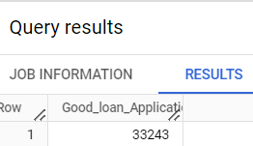

**Good Loan funded Amount**

SELECT sum(loan_amount) as good_loan_funded_amount

FROM `sql-project-413513.Financial_Analytics.Loan Repayment`

WHERE loan_status = "Fully Paid" OR loan_status= "Current"

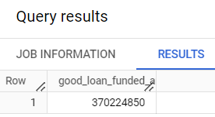

**Good Loan Amount Received**

SELECT sum(total_payment) as good_loan_amount_received

FROM `sql-project-413513.Financial_Analytics.Loan Repayment`

WHERE loan_status = "Fully Paid" OR loan_status= "Current"

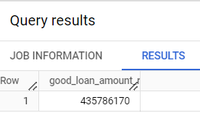

**BAD LOAN**

**Bad Loan Percentage**

SELECT

COUNT(CASE WHEN loan_status = "Charged Off" then id end)*100 / count(id) as Bad_Loan_Percentage

FROM `sql-project-413513.Financial_Analytics.Loan Repayment`

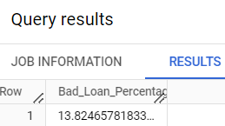

**Bad Loan Application**

‘SELECT count(id) as bad_loan_applications

FROM `sql-project-413513.Financial_Analytics.Loan Repayment`

WHERE loan_status = "Charged Off"

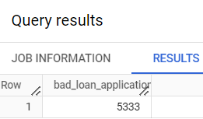

**Bad Loan Funded Amount**

SELECT Sum(loan_amount) as bad_loan_funded_amount

FROM `sql-project-413513.Financial_Analytics.Loan Repayment`

WHERE loan_status = "Charged Off"

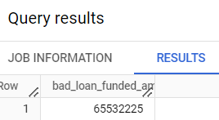

**Bad Loan Amount Received**

**SELECT Sum(total_payment) as Bad_loan_amount_received**

**FROM `sql-project-413513.Financial_Analytics.Loan Repayment`**

**WHERE loan_status = "Charged Off"**

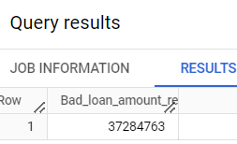

**SUMMARY**

**SELECT**

**loan_status,**

**Count(id) as Loan_Count,**

**Sum(total_payment) as Total_Amount_Received,**

**Sum(loan_amount) as Total_Funded_Amount,**

**Avg(int_rate)*100 as Interest_rate,**

**Avg (dti)*100 as Average_dti**

**FROM `sql-project-413513.Financial_Analytics.Loan Repayment`**

**GROUP BY loan_status**

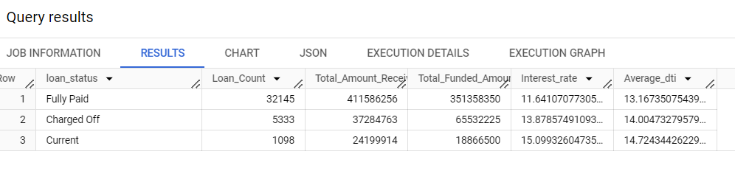

**SUMMARY MTD**

**SELECT**

**loan_status,**

**Sum(total_payment) as MTD_Total_Amount_Received ,**

**Sum(loan_amount) as MTD_Total_Funded_Amount,**

**FROM `sql-project-413513.Financial_Analytics.Loan Repayment`**

**WHERE issue_date between '2021-12-01' and '2021-12-31'**

**GROUP BY loan_status**

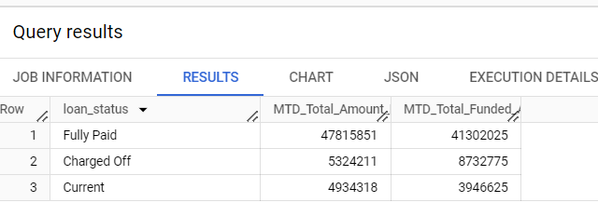

**0BANK LOAN REPORT | OVERVIEW**

**MONTH**

**SELECT**

**FORMAT_DATETIME ("%B",issue_date) as month_name,**

**count(id) as Total_Loan_Application,**

**Sum(loan_amount) as Total_Funded_Amount,**

**Sum(total_payment) as Total_Received_Amount,**

**FROM `sql-project-413513.Financial_Analytics.Loan Repayment`**

**GROUP BY FORMAT_DATETIME ("%B" ,issue_date)**

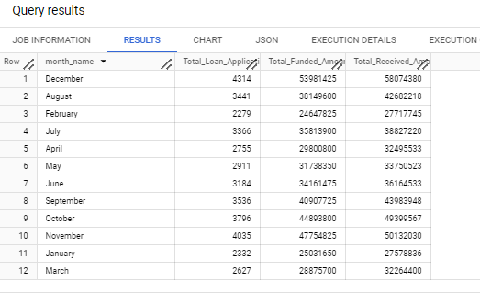

**STATE**

**SELECT**

**address_state,**

**count(id) as Total_Loan_Application,**

**Sum(loan_amount) as Total_Funded_Amount,**

**Sum(total_payment) as Total_Received_Amount,**

**FROM `sql-project-413513.Financial_Analytics.Loan Repayment`**

**GROUP BY address_state**

**ORDER BY address_state**

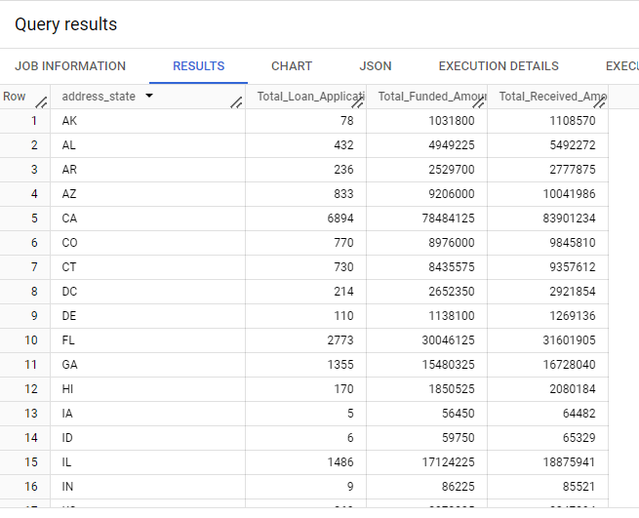

**TERM**

**SELECT**

**term,**

**count(id) as Total_Loan_Application,**

**Sum(loan_amount) as Total_Funded_Amount,**

**Sum(total_payment) as Total_Received_Amount,**

**FROM `sql-project-413513.Financial_Analytics.Loan Repayment`**

**GROUP BY term**

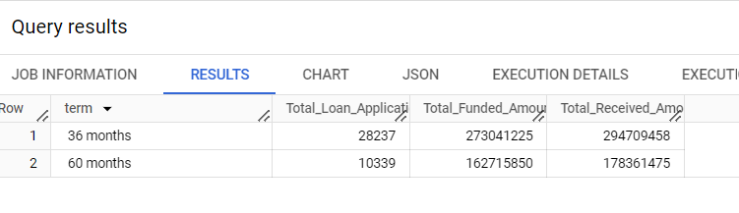

**EMPLOYEE LENGTH**

**SELECT**

**emp_length,**

**count(id) as Total_Loan_Application,**

**Sum(loan_amount) as Total_Funded_Amount,**

**Sum(total_payment) as Total_Received_Amount,**

**FROM `sql-project-413513.Financial_Analytics.Loan Repayment`**

**GROUP BY emp_length**

**ORDER BY count(id) DESC**

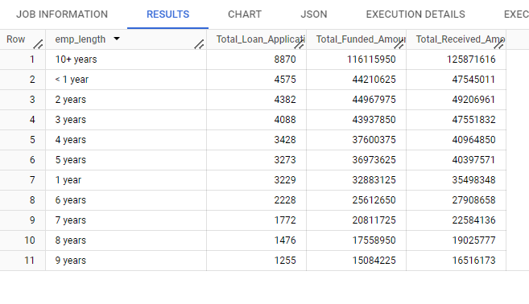

**PURPOSE**

**SELECT**

**purpose,**

**count(id) as Total_Loan_Application,**

**Sum(loan_amount) as Total_Funded_Amount,**

**Sum(total_payment) as Total_Received_Amount,**

**FROM `sql-project-413513.Financial_Analytics.Loan Repayment`**

**GROUP BY purpose**

**ORDER BY count(id)**

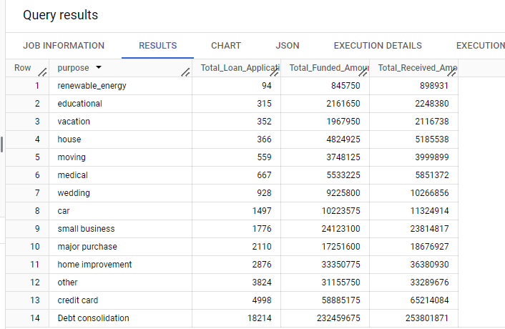

**HOME OWNERSHIP**

**SELECT**

**home_ownership,**

**count(id) as Total_Loan_Application,**

**Sum(loan_amount) as Total_Funded_Amount,**

**Sum(total_payment) as Total_Received_Amount,**

**FROM `sql-project-413513.Financial_Analytics.Loan Repayment`**

**GROUP BY home_ownership**

